Name ……………………………. Set ……..

4th Year

Dual Award

IGCSE CHEMISTRY

Homework
Booklet

2010-11

© Dr C R Lawrence

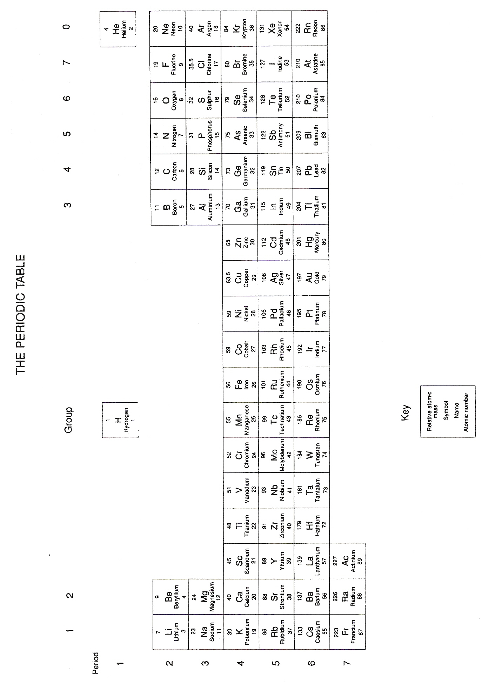

Homework | page
Atomic Structure | 1-2
Ionic Bonding | 3
Covalent Bonding | 4
What type of Structure? | 5
Structure and Bonding Revision | 6
Crude Oil | 7
Alkanes | 8
Combustion of Hydrocarbons | 9-10
Cracking and Alkenes | 11
Alkenes and Polymers | 12-13
RFM and % Mass Calculations | 14
Moles 1 – Empirical formulae and % Mass | 15
Moles 2 - Finding the formulae of compounds | 15
Moles 3 - Reacting Mass and a bit of Gas | 17
Periodic Table and Group 1 | 18
Group 7 | 19
Oxygen and Oxides | 20
Reactivity of Metals | 21
Reactivity Series | 22
Extracting Metals | 23
Electrolysis | 24
End of Year Examination Revision Questions | 25-28

Atomic Structure
Complete Chemistry for IGCSE - pg 28-33, pg 76. Qu 4 must be done on a separate sheet. Total / 50

- Complete the following table; [6]
Element | Atomic  Number | Mass  Number | Number  of protons | Number  of electrons | Number  of neutrons | Electron  Configuration
P | 7 | 14
Q |  | 23 | 11
R |  | 40 |  |  |  | 2,8,8,2

- The following table gives information about the electronic configuration of various elements.
Use this information to complete the final two columns in the table below. [3]
Element | Electron Configuration | Atomic Number | Group number  in the periodic table
A | 2:1
B | 2:3
C | 2:8:1
D | 2:8:4
E | 2:8:6
F | 2:8:8:2
3) Complete the information in the following table; [6]
Total Number  of electrons | Number of outer  electrons | Atomic Number | Electron Configuration | Group number  in the periodic table
 |  |  | 2:8:3
9 |  | 9
19

- The element neon occurs naturally as a mixture of isotopes, Ne (mass 20) and Ne (mass 22).
(Atomic Number Ne = 10)
- How many of each of the fundamental particles are present in the nucleus of Ne 22? [2]
- What is the electron configuration of Ne 20? [1]
- Why is neon a very unreactive element? [1]
- Explain the meaning of the word isotope. [2]
- What is the difference between the two isotopes of Neon? [2]
- Calculate the relative atomic mass of naturally occurring neon given than neon is a
mixture of 90% Ne 20 and 10% Ne 22. [3]
5) Use the information below to answer questions a-e;
Element | Mass Number | Atomic Number | Electron Arrangement
A | 12 | 6 | 2:4
B | 14 | 6 | 2:4
C | 19 | 9 | 2:7
D | 23 | 11 | 2:8:1
E | 40 | 18 | 2:8:8

- Which of the elements are Isotopes? [2]
- Which atom has 8 neutrons in it's nucleus? [1]
- Which element is unreactive? [1]
- Which two atoms have a valency (combining power) of 1? [2]
- Which two elements form ions with the same electronic configuration as neon? [2]

6) The atomic numbers and mass numbers of some elements are as follows;
Element | R | S | T | U | V | W | X | Y | Z
Mass number | 19 | 22 | 23 | 32 | 35 | 39 | 39 | 40 | 40
Atomic number | 9 | 10 | 11 | 16 | 17 | 18 | 19 | 19 | 20

- How many protons are there in the nucleus of T? [1]
- How many electrons are there in an atom of U? [1]
- How many neutrons are there in the nucleus of V? [1]
- Write down the electron configuration of W. [1]
- Which of the atoms are isotopes of the same element? [2]
- Which of the atoms would you expect to form an ion with charge of +2? [2]

7) Complete the following table; [8]
Particle | Atomic Number | Mass Number | Number of  Protons Electrons Neutrons
Aluminium atom (Al) | 13 | 27
Oxide Ion (O²⁻) | 8 |  | 8
Ca²⁺ ion |  |  | 20 20
Lithium atom (Li) |  | 7 | 3
Ionic Bonding
Total /36
Complete Chemistry for IGCSE - pg 36-43. Consult a periodic table for the appropriate data.

1) Complete the passage below using the following words:
loses ions ionic protons negative electrons positive gains
Atoms are neutral because they have the same number of ………………….. and ………………… .
If atoms lose or gain electrons they become electrically charged and are called ………… (they are
not atoms any more). If atoms gain electrons they become ……………….... ions, and if they lose
electrons they become ………………… ions.
When a metal reacts with a non-metal, the metal atoms …………….. electrons and the non-metal
atoms …………… electrons, forming an ……………….. compound. [8]

2) a) Complete the table about the metals. [5]
Element | Na | K | Mg | Ca | Al
Group number
Number of electrons in outer shell
Number of electrons needed to lose to get full outer shell
Number of electrons needed to gain to get full outer shell
Charge on the ion it forms

b) What do you notice about the Group number and the charge on the ions for metals? [1]

3) a) Complete the table about the non-metals. [5]
Element | Cl | Br | I | O | S
Group number
Number of electrons in outer shell
Number of electrons needed to lose to get full outer shell
Number of electrons needed to gain to get full outer shell
Charge on the ion it forms

b) What do you notice about the Group number and the charge on the ions for non-metals? [1]

4) Explain using a dot and cross diagram how calcium and oxygen react to form calcium oxide [4]

5) Draw a dot and cross diagram for each of the following substances;
a) Lithium fluoride, [3]

b) Potassium oxide, [3]

c) Calcium sulphide, [3]

d) Aluminium fluoride, [3]
Covalent Bonding
Complete Chemistry for IGCSE - pg 44-51. Total / 40
Consult a periodic table for the appropriate data.

1) Make a copy of the following table and complete the missing parts. [5]

Species | Atomic number | Mass  number | Number of protons | Number of neutrons | Electronic  configuration
C |  | 12 | 6
H | 1 |  |  | 1

2) Explain using a dot and cross diagram how carbon and hydrogen react to form the hydrocarbon
called methane, CH₄. [4]

3 a) Explain what is meant by Covalent bonding. [2]
b) How is covalent bonding different to Ionic bonding? [2]
c) How are ionic and covalent bonding similar? [2]

4) Explain why simple molecular substances, such as methane, have very low melting points? [4]

5) Other than a low melting point give two properties of methane. [2]

6) Draw a dot and cross diagram for each of the following substances;

- Chlorine Cl₂. [3]

- Hydrogen sulphide, H₂S. [3]

- The compound formed between Carbon and chlorine. [3]

- The compound formed between Phophorus and hydrogen. [3]

e) Carbon dioxide, CO₂. [3]

Independent Study

7) Explain in terms of their structure why;
- diamond is the hardest substance on Earth
- graphite is soft enough to be used as pencil lead
although they are both allotropes of carbon.

Please give references for your research. [4]

What type of structure?
Complete Chemistry for IGCSE - pg 36-55 Total / 30

1) Explain each of the following about melting and boiling points:

- Simple molecular substances have low melting and boiling points. (2)

- Giant covalent substances have very high melting and boiling points. (2)

- Ionic substances have high melting and boiling points. (2)

- Metals have quite high melting and boiling points. (2)

2) Explain each of the following about electrical conductivity:

- Simple molecular substances do not conduct at all. (2)

- Giant covalent substances do not conduct, apart from graphite. (3)

- Ionic substances conduct when melted or dissolved, but not when solid. (3)

- Metals conduct as solids and when melted. (2)

- Classify the substances A to F as having either ionic, simple molecular,
giant covalent or metallic bonding.
Explain your choice. (12)

 |  | Melting point (°C) | Boiling point (°C) | Electrical conductivity as solid | Electrical conductivity as liquid | Electrical conductivity in water
 | A | 156 | 245 | good | good | good
 | B | 135 | 205 | poor | poor | poor
 | C | 356 | 783 | poor | good | insoluble
 | D | 584 | 1356 | poor | good | good
 | E | 1836 | 3720 | poor | poor | insoluble
 | F | -39 | 357 | good | good | insoluble

Structure and Bonding – Revision
Complete Chemistry for IGCSE - pg 36-55 Total / 43

1. Draw up a table with the headings “ion”, “number of protons”, “number of neutrons”, “number of electrons”, “arrangement of electrons”, and fill it in for these ions.
23Na+ , 40Ca2+ , 15N3- , 35Cl- ( show electrons as e.g. 2.8.6) 8

2. a) Name the three potentially strong types of chemical bonds that can exist in substances. 1
b) Using the answers to part (a) state which type of chemical bond is present in the following substances :-
aluminium oxide ; oxygen ; carbon dioxide ; aluminium ; sodium fluoride; sodium. 3

3. a) Draw dot/cross electron bonding diagrams to illustrate the bonding in :-
(i) sodium chloride (ii) methane (CH₄) (Outer shells only) 4

b) Draw labelled diagrams to illustrate the structure of:- 4
(i) sodium chloride (ii) methane N.B! these are not dot and cross diagrams.

4. Explain the following in terms of bonding and structure ideas :-
. (i) Silicon dioxide and carbon dioxide both contain covalent bonds but the former melts at
1700ºC whereas the latter is a gas at 0ºC.
(ii) Sodium oxide, carbon dioxide and silicon dioxide are all poor conductors of electricity
when solid, but only sodium oxide becomes an excellent conductor when molten. 4

5. a) Draw a labelled diagram along with some descriptive English to illustrate the structure and
bonding to be found in a typical metal such as copper. 4

b) Use your answer in (a) to explain the following typical physical properties of a metal :-
i) All metals are good conductors of electricity as solids.
ii) Most metals are extremely malleable 4

6. Study the table of properties of some substances and answer the questions below.
(Each substance may be used once, more than once, or not at all.)

Property | melting | boiling | ability to | conduct | when:
 | point/oC | point/oC | solid | melted | dissolved  in water
A | 804 | 1465 | poor | good | good
B | 659 | 2450 | good | good | insoluble
C | –114 | –85 | poor | poor | poor
D | 2600 | 2600 | poor | poor | poor
E | 275 | 1200 | poor | good | insoluble
F | –113 | 78 | poor | poor | poor
G | 37 | 260 | good | good | reacts

State the structure and bonding in each substance A to G. 7
Crude Oil

Complete Chemistry for IGCSE - pg 238-241 and 244-245 Total / 30

1) Crude oil is a mixture of many saturated hydrocarbons which can be separated by fractional distillation.  a) Describe briefly how the apparatus could be used to obtain the kerosene fraction (boiling point 150-240°C) from crude oil, using this apparatus | 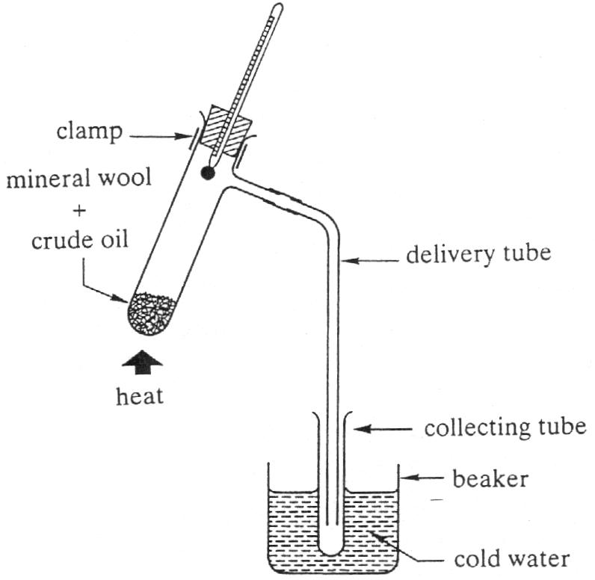 | [3]
b) Why is the test tube kept cool in the beaker? [1]
c) What piece of evidence can be used to show that kerosene is a mixture of hydrocarbons? [1]
d) Describe some fundamental differences between this laboratory separation and the
industrial process used to purify crude oil. [3]

2) Dr Lawrence has collected three fractions after distilling crude oil using the apparatus in Qu 1).
However, at the end of the experiment, he gets the tubes mixed up.
Suggest three ways that he can find out the order they were collected in. [3]

3) Draw a labelled diagram of a fractionating column giving two uses for each of the fractions obtained. [4]

4) The petroleum fraction contains a hydrocarbon with the molecular formula, C₇H₁₆.
i) What is a hydrocarbon? [2]
ii) Write a balanced equation for the complete combustion of C₇H₁₆. [3]
iii) What would the products of incomplete combustion of C₇H₁₆ be? [2]

5) Describe and explain the main environmental concerns related to the;
i) extraction,
ii) transport,
iii) purification
iv) use of crude oil? [4]

6) It is predicted that the reserves of crude oil may run out in the next 50-60 years.
Explain two ways in which this will impact on our everyday lives. [2]

7) What can be done to increase the life of the current oil reserves? [2]

Alkanes
Complete Chemistry for IGCSE - pg 244-245. Total / 26
1) Copy and complete the following table of alkane properties.
Name | Formula | Number of  Carbon atoms | Boiling Point oC | State at room temperature
Methane | CH4 | 1 | -161 | Gas
Ethane |  |  | - 88
Propane

Butane |  |  | - 0.5
Pentane |  |  | 36
[3]
2) Plot a graph of boiling point of the alkanes (vertical axis) against the number of carbon atoms in their molecules (horizontal axis). [5]

3) Use your graph to predict the boiling point of;
i) Propane ii) Hexane (C6H8) [2]

4) What property of the graph makes these predictions accurate? [1]

5) Explain the shape of the graph in terms of the intermolecular forces between the molecules. [2]

6) Decane is the alkane with ten carbon atoms in its molecules.
i) If the formula of decane is written CxHy, what are the values of x and y? [2]
ii) Draw the structural (displayed) formula of a decane molecule. [2]
iii) This is not the only possible structural formula that satisfies the molecular formula of decane.
Draw three other possible forms that have the same molecular formula. [5]

7) Write a balanced equation for the complete combustion of decane. [3]
Combustion of Hydrocarbons
Complete Chemistry for IGCSE - pg 240-241 and 244-245 Total / 32

1) The diagram shows a simplified fractionating tower. Some of the products which may be obtained when crude oil is fractionally distilled are labelled.
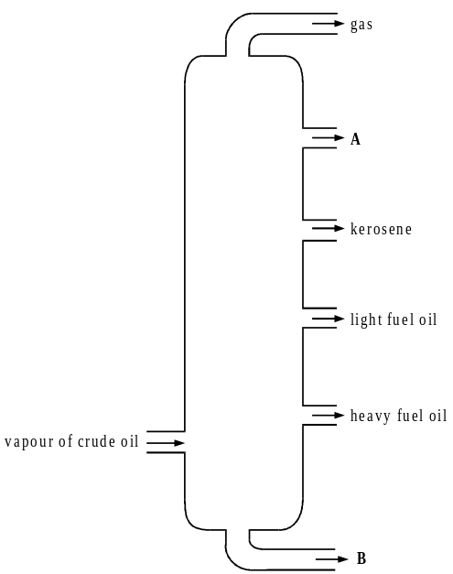
Give the names of fractions A and B and state a use for each. [4]

2) Propane and Hexane both hydrocarbons that belong to the homologous series called alkanes.
a) What is a hydrocarbon? [2]
b) What is meant by the term homologous series. [2]
c) Write the molecular formula of i) propane,
ii) hexane? [2]
d) Why are propane and hexane in the homologous series called alkanes? [2]

3) Propane and hexane are both used as fuels.
a) i) Write a word and balanced symbol equation for the complete combustion of propane. [4]
ii) Describe how you would test for the products obtained from the complete combustion of propane.
Include any expected observations. [4]
iii) If there is insufficient oxygen, incomplete combustion occurs and other substances are formed.
Name one of these other substances formed and explain why it is so dangerous. [3]
b) Write a balanced symbol equation to represent the complete combustion of hexane. [3]
4) Which of these structures represents a butane molecule?
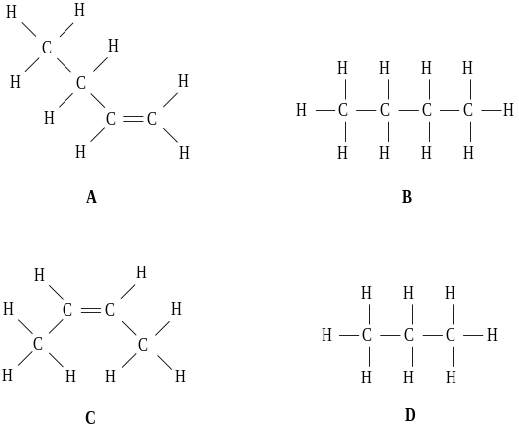 [1]

5) When propane is shaken with bromine water, the bromine water will
A turn from colourless to brown
B turn from orange to clear
C turn from orange to colourless
D remain orange [1]

6) Many useful products are obtained by the fractional distillation of crude oil.
Which of the following statements about this process is correct?
A Each fraction is a pure substance
B Fractions which ignite easily are collected from the bottom of the column
C Each fraction contains a number of different hydrocarbons
D Fractions with the lowest boiling points are collected from the bottom of the column [1]

7) Which of these dot and cross diagrams correctly represents a molecule of ethene?
× represents an electron from a carbon atom
- represents an electron from a hydrogen atom

A | 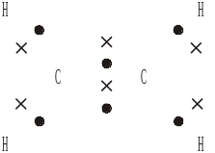 | B | 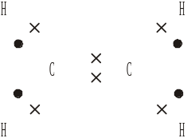 | C | 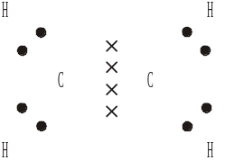 | D | 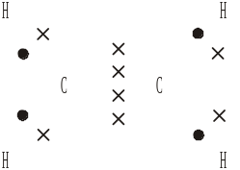
[2]
8) Many fuels are hydrocarbons.
Complete combustion of hydrocarbons produces
A water only
B water and carbon dioxide
C carbon dioxide only
D carbon
[1]
Cracking and Alkenes

Complete Chemistry for IGCSE - pg 246-247 and 242-243. Total /30

1) Draw a diagram to clearly show the shape of a methane molecule and an ethene molecule.
Give a clear description of the shapes you have drawn. [5]

2a) Hexene is a liquid alkene. Draw any three isomers of hexene. [3]

b) For one of these isomers, draw the structure of the product of its reaction with bromine water.
Make it clear which isomer you have chosen. [3]

3. Explain why it is necessary for oil companies to crack the long chained alkanes produced from fractional distillation. [3]

4. Propane can be catalytically cracked to produce propene and hydrogen.
a) Use graphical formulae to represent the reaction. [3]

b) Give a use for the hydrogen produced in the chemical plant where cracking occurs. [1]

5) Decane can also be cracked.
a) Draw a labelled diagram of the apparatus used in the lab to crack decane. [4]

b) What is the physical evidence that cracking has occurred? [2]

c) Write a balanced symbol equation for the cracking of decane. [3]

d) Write a balanced equation using graphical formulae for the cracking of decane. [3]

Alkenes and Polymers
Complete Chemistry for IGCSE - pg 246-247, 256-259 and 264-365 Total /37

1) The following diagram shows some of the reactions of ethene.
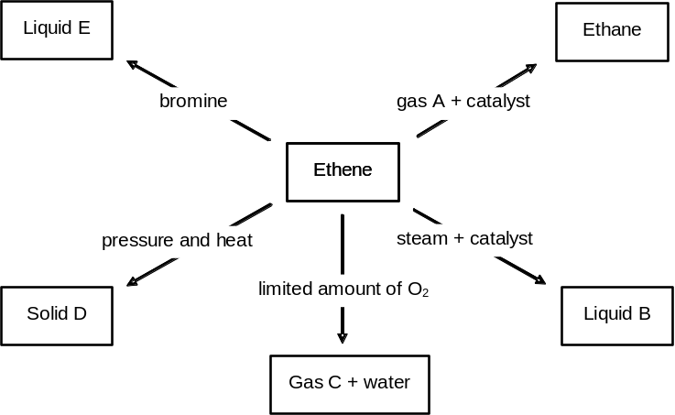

a) Draw the structural formulas for ethane and ethene. [2]

b) Give the names for: gas A, liquid B, gas C, solid D [4]

c) Write a symbol equation to show the reaction between ethene and water to form liquid B. [2]

d) Give the name and draw and the structural formula for liquid E. [2]

e) Ethene is an unsaturated compound.
By means of gas A, ethene is converted into ethane, a saturated compound.
Give one commercial application of this type of reaction. [1]

f) Write balanced equations for the following reactions.
Draw the structural formula of any organic products.

- ethene + hydrogen →

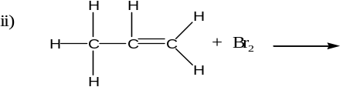 [4]

2) Ethene can be used to make the polymer poly(ethene).

a) What is a polymer? [2]

b) What is a monomer? [1]
c) Draw and name the polymer that would be formed from the alkene methylpropene. | 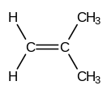 | [2]

3 The diagram above shows a simplified flow chart of an industrial process used to make poly(ethene) [polythene] from crude oil.

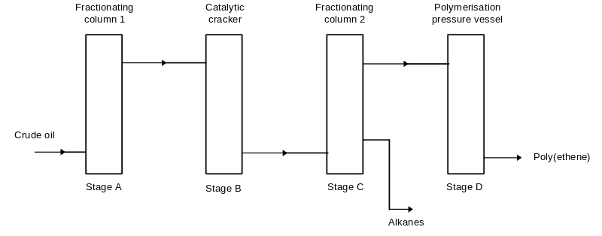
a) What is the purpose of the catalytic cracker? [2]

b) Why is fractionating column number 2 necessary? [2]

c) List the stages in the process which require energy. [1]

d) Complete the following equation to show how three ethene molecules link together to form part of a poly(ethene) molecule. [2]

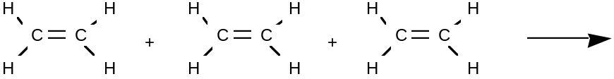

Independent Study

4 There are two methods of polymerisation, condensation polymerisation and addition polymerisation.
a) Describe how the two methods are similar. [2]
b) Describe how the two methods are different. [2]

Challenge of the week

5 a) i) Most plastics are non bio-degradable. Explain what this term means. [2]

ii) What problem does this cause? [2]

b) The structure of two polymers is shown below. For each polymer, name one toxic substance produced when they are burned (apart from carbon monoxide). [2]
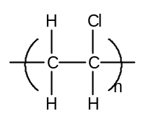 | 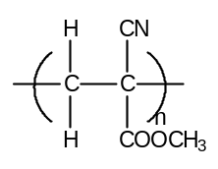
poly(chloroethene)  PVC | poly(methyl 2-cyanopropenoate)  superglue

RFM and % Mass Calculations

Complete Chemistry for IGCSE - pg 76-79 Total / 25
I know it’s tiresome, but please show all your working - half the marks go on working!!

1 a) What is the relative atomic mass of an element measured relative to? [1]
b) What is the relative atomic mass of the following elements:
i) Na ii) O iii) S [3]

2 a) Complete the table for the isotopes in a sample of bromine.
Mass number | Number | Number | Number | Percentage of each
of isotope | of protons | of neutrons | of electrons | isotope in sample
79 | ………… | ………… | ………… | 53
81 | ………… | ………… | ………… | 47
[3]
b) Explain why isotopes have a different mass number. [1]
c) Use the information in the table to calculate the relative atomic mass of bromine.
(pg 76 of your textbook may help). [2]

3) Work out the relative formula masses (RFM) of the following substances.
(a) Na₂SO₄ (b) CO₂ (c) NaOH (d) Na₂CO₃ (e) Chloride ions Cl⁻ [5]

4) Calculate the % by mass of sodium in the Sodium sulphate (Na₂SO₄).
Use your answer to calculate the mass of sodium in 117g of sodium sulphate. [3]

5) Calculate the % by mass of nitrogen in Ammonium nitrate, NH₄NO₃
Use your answer to find the mass of nitrogen that can be obtained from 570g of ammonium nitrate.
[3]

Independent Learning
Read Complete Chemistry for IGCSE - pg 80-81

Chemists use moles as their counting unit.
Moles = mass of substance (in grams)
relative formula mass (RFM)

6) Find the number of moles in each of these substances:
(a) 284 g of sodium sulphate, Na₂SO₄
(b) 11 g of carbon dioxide, CO₂
(c) 1 kg of sodium hydroxide, NaOH
(d) 106 g of sodium carbonate, Na₂CO₃ [4]

Moles 1 – Empirical Formulae and % Mass
Complete Chemistry for IGCSE - pg 80-85 Total / 30
Please show all your working.

1) Calculate the number of moles in each of these substances:
(a) 54 g of water
(b) 0.16 g of oxygen gas
(c) 8.5 g of ammonia (NH₃)
(d) 5 kg of aluminium oxide (Al₂O₃) [4]

2) Calculate the mass of:
(a) 0.50 moles of H₂SO₄
(b) 10.0 moles of CO₂
(c) 3 moles of NaOH
(d) 2.00 moles of MgCl₂ [4]

3) Calculate the % by mass of oxygen in Ca(OH)₂. [2]

4) For each of the following, calculate the empirical formula:
a) 57.5% sodium 40% oxygen 2.5% hydrogen
b) 82% nitrogen 18% hydrogen
c) 20% aluminium 80% chlorine. [6]

5) An oxide of sulphur contains 40 % sulphur and 60 % oxygen.
Its relative molecular mass is 80.
Find both the empirical and the molecular formula of the oxide. [4]

- A compound contains 40.0g of carbon, 6.7g of hydrogen and 53.5g of oxygen.
It has a relative molecular formula of 60.
Find both the empirical and the molecular formula of the compound. [4]

7) A known mass of black copper oxide was converted to copper metal by heating it in a stream of hydrogen gas, as shown in the diagram.
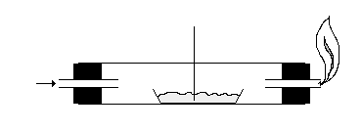
The following data was collected:-

Mass of tube empty = 27.54g
Mass of tube + copper oxide = 29.14g
Mass of tube + copper metal = 28.82g

Complete the table below and find the
simplest formula of the copper oxide.
Copper oxide

Gas in

HEAT

Element | Mass (g) | Moles | Mole Ratio
Copper
Oxygen

Calculate the empirical formula of the copper oxide. [6]

Moles 2 - Finding the formulae of compounds
Complete Chemistry for IGCSE - pg 82-85 Total / 32

- Lucy and Peter carried out an experiment to determine the chemical formula of magnesium oxide. Their results are shown in the table below;

 | Mass of Crucible (g) | Mass of Crucible  + magnesium (g) | Mass of Crucible  + magnesium oxide (g)
Lucy | 16.25 | 18.25 | 19.58
Peter | 18.45 | 20.45 | 21.57

a) Calculate the formula for magnesium oxide from Lucy’s results. [4]
b) Calculate the relative formula mass (RFM) of magnesium oxide with this formula. [2]
c) Calculate the % of magnesium in the magnesium oxide. [2]
Peter’s results do not give the correct answer for the formula.
d) Suggest some possible experimental reasons for Peter’s incorrect results. [4]

2) A mixture of copper and sulphur powder reacts when heated in a test-tube. A sample of the powdered copper was placed inside the tube followed by a large excess of sulphur. The mixture was then heated strongly until no further change occurred. After cooling the tube was weighed and a dark blue solid had formed. The results from the experiment were;
Mass of empty test-tube = 16.20g
Mass of test-tube + copper = 16.72g
Mass of test-tube + compound = 16.98g

a) Describe the appearance of copper and sulphur powders. [1]
b) Give one piece of evidence that a new compound has been formed. [1]
c) What mass of copper was used in the experiment? [1]
d) Explain why it was not necessary to record the mass of the sulphur used. [1]
e) What mass of sulphur combined with the copper? [1]
f) Calculate the empirical formula of the compound formed. [4]
g) What is the compound called? [1]

3) Below are the results of a similar experiment used to find the formula of an oxide of copper.

Mass of empty test-tube = 13.80g
Mass of test-tube + copper = 20.15g
Mass of test-tube + compound = 21.75g

Use the results to find the empirical formula of the oxide. [4]

4) Calculate the empirical formula of the following compounds:
a) The oxide of beryllium that produces 18g of beryllium from 50g of beryllium oxide.
b) The iodide of tin that produces 2.00g of tin form 10.54g of tin iodide. [6]

Moles 3 - Reacting Mass and a bit of Gas
Complete Chemistry for IGCSE - pg 94-95 and 96-97 (for the bit of gas). Total / 30

Reacting Mass

1. Explain the three step method used to calculate the mass of a product formed from a known mass of a reactant. [2]

2. Magnesium carbonate reacts with hydrochloric acid according to the equation:
MgCO3(s) + 2HCl(aq) → MgCl2(aq) + H2O(l) + CO2(g)
What mass of pure hydrochloric acid is needed to react with 4.2g of magnesium carbonate?
[4]

3. When nonane burns the equation is:
C9H20(g) + 14O2(g) → 9CO2(g) + 10H2O(l)
What mass of nonane C9H20 will give 1 kg of CO2? [4]

4. 2Pb(NO3)2 (s) → 2PbO(s) + 4NO2(g) + O2(g)
What mass of PbO can be made from 5g of lead nitrate Pb(NO3)2? [4]

5. Iron is formed in the Blast Furnace by reduction of heamatite with carbon monoxide according to the equation; Fe2O3 + 3CO → 2Fe + 3CO2
What mass of iron can be obtained by reduction of 8 tonnes of haematite Fe2O3?
Assume a plentiful supply of carbon monoxide. [4]

6. Aluminium is formed in the electrolysis of Bauxite according to the equation;
2Al2O3 → 4Al + 3O2
i) What mass of oxygen is obtained from the electrolysis of 60 kg of Bauxite Al2O3?
ii) What mass of aluminium is obtained from the electrolysis of 60 kg of Bauxite? [4]

The Gas Bits
Remember - 1 mole of any gas occupies 24 dm³ and moles of gas = volume (in cm³)
24000
7. Glucose is often fermented to produce ethanol and carbon dioxide gas;
C6H12O6(s) → 2CH3CH2OH(l) + 2CO2(g)
In attempt to perform this reaction in the laboratory Gavin used decided to react 35 g of glucose.
What volume of carbon dioxide gas would he make? (Show all your working). [4]

8. Zinc can be purified from it’s oxide by reacting it with Carbon monoxide.
ZnO(s) + CO_{(g)} → Zn(s) + CO2(g)
What volume of carbon monoxide is needed to produce 195 g of zinc? (Show all your working). [4]

Periodic Table and Group 1
Complete Chemistry for IGCSE - pg 58-63 Total / 35

- a) Mendeleev originally arranged the elements in order of atomic mass.
However he swapped the elements argon and potassium so that argon was in group 8 and
potassium was in group 1. Explain why he did this. [3]
b) By what order are elements listed in the modern version of Mendeleev’s table? [1]

- Element X has the configuration 2, 8, 18, 18, 7
i) Which group and period of the periodic table is X in?
ii) What is the atomic number of element X?
- Identify element X. [4]

- Explain why the valency of the alkali metals is always one. [1]

4. Each of the elements in Group 1 react with water in the same way.
a) Give a balanced symbol equation for the reaction of sodium with water. [2]
b) Hydrogen is also produced in the reaction with water.
Describe the chemical test for hydrogen and write a balanced symbol equation for the reaction
taking place in the test. [4]

5. Group 1 elements tarnish in air to give a white, solid oxide.
Write a balanced symbol equation with state symbols for the reaction of potassium with air. [2]

6. Rubidium comes just below potassium in Group 1. Use this information, and your knowledge of the
chemistry of potassium, to answer the following questions.
- Would you expect rubidium to be more or less reactive than potassium?
Explain your answer in terms of electrons. [4]
b i) Describe what you would see if a piece of rubidium was added to a trough of water. [2]
ii) Write a balanced equation for the reaction and name the products formed. [2]
iii) Describe and explain what would happen if a universal indicator solution was added to the
water after the reaction. [2]
- Rubidium bromide can be formed as shown in the following reaction:
2Rb + Br₂ → 2RbBr
Calculate the mass of rubidium bromide that could be formed from 3.4 g of rubidium.
[RAM: Rubidium = 85, bromine = 80] [3]

Independent Study

- Carry out some of your own research into Group 1 elements and record your findings.
Please give references for your research.
Possible topics you could select from. [5]
- Extraction of sodium from sodium chloride
- Uses of sodium and its compounds
- Potassium chloride – a “non-toxic lethal injection.”
- Health aspects of sodium
- Health aspects of potassium

Group 7
Complete Chemistry for IGCSE - pg 64-65, 61, 290 Total / 30

1. List the symbols of the halogens in order of increasing reactivity. [1]

2. How do the following properties of the halogens change as the group is descended?
a) Boiling point.
b) Relative atomic mass.
c) Strength of forces between the diatomic molecules. [3]

3. Draw a diagram to represent an atom of fluorine.
Explain in terms of fluorine's electronic structure why fluorine has a valency of 1. [3]

4. Chlorine-35 and chlorine-37 are isotopes. What is the difference between them? [2]

5. Fluorine is the halogen that occurs at the top of group VII. What would happen if......
a) Fluorine was exposed to damp blue litmus. [2]
b) Iron wool was placed in a gas jar containing fluorine. [2]
c) Fluorine was bubbled through a solution of potassium chloride. [2]

6. For 5b and 5c above, write balanced symbol equations. [4]

Challenge of the week

7. A student was given three bottles from which the labels had been removed.
The bottles all contained white, crystalline solids.
He was told that the bottles contained sodium chloride, potassium chloride and sodium iodide. Describe suitable tests which he could carry out to work out which bottle contained which salt. You should include the names of reagents and methods used as well as the expected results for each compound. [6]

Independent Study

8. Carry out some of your own research into Group 7 elements and record your findings.
Possible topics you could select from. Please give references for your research.
- Hydrogen fluoride – useful but nasty.
- The use of chlorine – modern and historical.
- The use of halogens in photography.
[5]
Oxygen and Oxides
Complete Chemistry for IGCSE - pg 202-203, 222-225 and 212 Total / 50

- List the three main gases in dry air, and give the percentage of each one. [3]

- An experiment was carried out to find the % of oxygen in air. 100 cm³ of air was passed
from side to side over copper that was being heated.
At the end of the experiment there was 81 cm³ of gas left in the syringes.
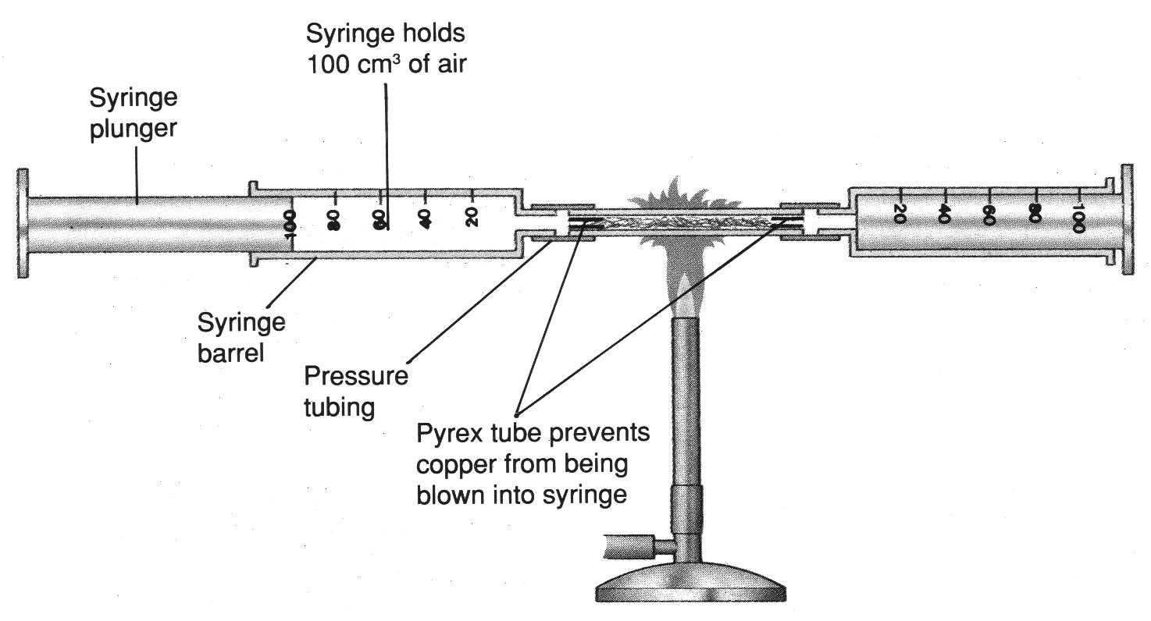

- Write a balanced symbol equation for the reaction that takes place in the experiment. [2]
- Describe the basic idea behind this experiment. [3]
- How could you tell that the reaction between the copper and the oxygen had finished? [2]
- Why should the gas be left for a few minutes before reading the volume left at the end? [2]
- What is the percentage of oxygen in air according to this experiment? [1]
- Give two reasons why the value in 2 e) is different from that in Qu 1)? [2]
- Describe how oxygen is obtained from air. [2]

- Draw a dot and cross diagram for oxygen gas, O₂. [2]

- a) Write balanced equations for the reactions between oxygen and;
- Sodium
- Calcium
- Sulphur
- Nitrogen. [8]

b) What would be the pH of the solutions made from the products formed in part a)? [2]

6. Explain why sulphur dioxide is a pollutant gas. Include an equation in your answer. [3]

- a) Describe the laboratory preparation of carbon dioxide gas. [3]
- Give two used of carbon dioxide gas. [2]
- Explain why carbon dioxide is a pollutant gas. [3]

8. a) Describe the chemical test for hydrogen gas. [2]
b) Write a balanced equation for the test for hydrogen. [2]
c) Explain why hydrogen is often described as the ‘fuel of the future’. [2]
d) Describe a chemical test for water. [2]
e) Describe a physical test to show that water is pure. [2]

Reactivity of Metals
Complete Chemistry for IGCSE - pg 174-175 Total /40

1) Write balanced symbol equations for the following reactions;
- Sodium metal reacting with water to form sodium hydroxide. [2]
- Calcium metal reacting with water to form calcium hydroxide. [2]

2) In order to react metals with steam we use the apparatus below;
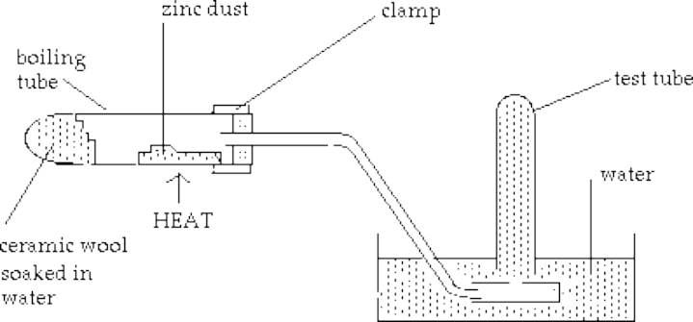
a) What evidence will there be that a chemical reaction has occurred? [2]
b) Write a word equation for the reaction between the zinc and the steam. [1]
c) Write a balanced chemical equation for the reaction. [2]
d) Describe the test for the gas produced from the reaction and write a balanced chemical equation for its reaction (if any) with the air. [3]

3) Only metals above hydrogen in the reactivity series are able to displace hydrogen from acids.
Use the following pieces of information about the chemistry of the five metals zinc (Zn), chromium (Cr),
Silver (Ag), nickel (Ni) and Rubidium (Rb) to answer parts (a) to (e) of this question.
Information;
- Chromium reacts with dilute hydrochloric acid to give hydrogen and aqueous chromium(III) chloride.
- Silver does not react with dilute hydrochloric acid.
- Nickel reacts slowly with hydrochloric acid to give aqueous nickel(II) chloride.
- Zinc reacts vigorously dilute hydrochloric acid.
- When a piece of Rubidium is placed in dilute hydrochloric acid there is an extremely violent explosion.
- The combining powers (valencies of Rubidium and Silver are 1).

(a) List the Five metals and Hydrogen in order of increasing reactivity. [1]
(b) Which metal is most likely to react with cold water? [1]
(c) Which metal will not react with steam? Explain your answer. [2]
(d) Write balanced symbol equations for the following reactions;
- Chromium reacting with dilute hydrochloric acid.
- Nickel reacting with dilute hydrochloric acid
- Zinc reacting with dilute hydrochloric acid
iv) Rubidium reacting with dilute hydrochloric acid
v) Zinc oxide + Rubidium
vi) Chromium + Nickel(II) chloride
vii) Chromium + Rubidium Sulphate
viii) Silver chloride + Zinc. [24]
Reactivity Series
Complete Chemistry for IGCSE - pg 174-178 Total / 35

1. Write balanced symbol equations for the following if a reaction occurs;

a) calcium is added to water [2]

b) silver is added to dilute hydrochloric acid [2]

c) lead(II) oxide is heated with magnesium [2]

d) calcium is heated in the air [2]

e) aluminium is heated with lead(II) oxide [2]

f) zinc is heated with steam [2]

g) magnesium is added to cold water [2]

h) zinc is added to dilute nitric acid [2]

i) iron(III) oxide is heated with coke [2]

j) aluminium is heated in dilute sulphuric acid [2]

2. Vanadium is a transition metal and comes between aluminium and zinc in the reactivity series. Predict how you would expect vanadium to react in each of the following cases. In each case name the products you would expect to be formed.

a) vanadium is heated in air [2]

b) vanadium is added to cold water [2]

c) vanadium is heated in steam [2]

d) vanadium is added to dilute hydrochloric acid [2]

e) vanadium oxide is heated with aluminium [2]

f) magnesium oxide is heated with vanadium [2]

3. Choose any reaction from question 2 to illustrate the term REDOX. [3]

Extracting Metals
Complete Chemistry for IGCSE - pg 186-189 Total / 30

- The three raw materials placed in the top of a blast furnace for the production of iron are coke (a form of carbon), limestone and iron ore.
- Give the chemical names for coke, limestone and iron ore. [3]
- Give the chemical formulae for limestone and iron ore. [2]
- The first reaction is the combustion of coke.
Write a balanced chemical equation for this reaction. [2]
- Other than to form Carbon dioxide, why is the combustion of coke an important reaction in
the blast furnace? [2]
- The carbon dioxide produced then reacts with more coke to form carbon monoxide.
Write a balanced chemical equation for this reaction. [2]
- The carbon monoxide produces iron from the iron ore.
Write a balanced chemical equation for this reaction. [2]
- Explain the purpose of the limestone. [2]
- Write a balanced equation for the formation of slag. [2]
- Explain how the slag and the waste gases from the furnace are useful. [2]
- What is the reducing agent in the blast furnace? [1]
- What does a reducing agent do? [1]

2. A student was trying to extract the metals from lead oxide and aluminium oxide.
She heated each oxide with carbon in a fume cupboard as shown below.
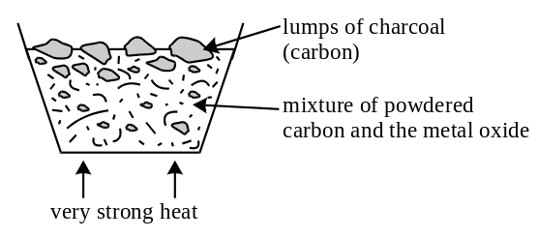
a) She was able to extract lead from lead(IV) oxide but not aluminium from aluminium oxide.
Explain the results of these experiments. [3]
b) Write a balanced equation for the reaction between lead(IV) oxide and carbon. [3]
c) What mass of carbon is needed to completely reduce 59.75g of lead(IV) oxide?
(Hint – Use the 3 step method) [3]

Electrolysis
Complete Chemistry for IGCSE - pg 134-137 Total / 36

1 a) Explain why simple molecular substances do not conduct electricity.
b) Explain why metals conduct electricity.
c) Explain why giant covalent substances, apart from graphite, do not conduct electricity.
d) Explain why ionic substances do not conduct electricity as solids but do when molten or dissolved in water. [8]

2) Draw a table to clearly show your answers in this question.
When each of the following ionic substances is melted and electrolysed:
- predict what would be produced at the positive electrode
- give the half equation for the reaction at the positive electrode
- predict what would be produced at the negative electrode
- give the half equation for the reaction at the negative electrode
a) molten lead(II) bromide.
- molten sodium chloride.
- molten aluminium oxide.
- molten magnesium oxide. [24]

3) a) Define oxidation and reduction in terms of electrons.
b) At which electrode does oxidation take place in electrolysis?
c) At which electrode does reduction take place in electrolysis? [4]

4th Year – Dual Award

Summer Revision Questions

Structure and Bonding
1. For each of the following give the number of protons, neutrons and the electronic structure.

 | Number of Protons | Number of Neutrons | Electronic Configuration
19F atom
39K+ ion
18O2- ion

2. Rubidium consists of two isotopes, rubidium–85 and rubidium–87. If the relative abundances are 72% and 28% respectively, what is the average relative atomic mass of rubidium?

3. Draw a dot & cross diagram to represent the bonding in;
i) Magnesium chloride.
ii) Sodium oxide

4. Draw a dot & cross diagram to represent the bonding in;
i) Methane (CH4)
ii) Nitrogen (N₂)
iii) Carbon dioxide (CO2)

5. Explain the following statements;
a) Bromine is a liquid at room temperature.
b) Carbon in the form of diamond is very strong but in the form of graphite it is soft enough to be
used in pencils.
c) Carbon dioxide is a gas whereas silicon dioxide (sand) is one of the hardest substances on Earth.
d) Metals are malleable and conduct electricity when solid.
e) Sodium chloride will not conduct electricity when solid but will when molten or when dissolved in
water.

6. Draw a diagram to show the structure of the following;
i) Methane gas.
ii) Sodium chloride solid.
- Diamond.
- Graphite.

Organic Chemistry
1 a) Write an equation for the complete combustion of butane.

b) Explain what happens if butane is burnt in a restricted supply of air. Why is this dangerous?
Write an equation for the reaction.

2. Describe the process used to separate the components in crude oil.

3. What is a homologous series?

4 a) Describe in words what happens when an alkane is cracked.

b) Write an equation using structural formulae with all the bonds, to show what happens when
octane is cracked.

c) Describe a chemical test you could use to see if this reaction had worked successfully.
Write an equation for the reaction which occurs, using structural formulae.

5. Using ethene as an illustration, explain what is meant by the terms monomer, polymer and
addition polymerisation.

6. Draw out the repeating unit of the polymer formed from each of the following monomers:
- Propene
- Chloroethene.

7. What are isomers?

Calculations
1. A compound contains 40.0 g of carbon, 6.7 g of hydrogen and 53.5 g of oxygen. It has a relative molecular formula of 60.
Find both the empirical and the molecular formula of the compound.

2. Chlorine is made in the laboratory by oxidising concentrated hydrochloric acid with manganese(IV) oxide:
MnO2 + 4HCl → MnCl2 + 2H2O + Cl2.
(a) Find the mass of HCl solution which is needed to form 8.60g of chlorine.

(b) Find the mass of MnO₂ which is needed to form 5 tonnes of chlorine.

3. 6.25g of blue hydrated copper(II) sulphate, CuSO₄.xH₂O, (x unknown) was gently heated
in a crucible until the mass of remaining white anhydrous copper(II) sulphate CuSO₄ was
4.00g. Calculate x, the number of moles of water in CuSO₄.xH₂O.

Periodic Table
1 a) In what order are elements placed in the Periodic Table?
b) What are the electronic structures of chlorine and potassium?
c) Using the electronic structures describe why chlorine and potassium are not in the same period?
d) What is the electronic arrangement of a potassium ion?
e) What name is used to describe the change taking place when potassium turns into an ion?

2. Most elements can be classed as either metals or non-metals.
a) To which class do (i) chlorine and (ii) potassium belong?
b) Explain your answer to (a) in terms of the electron arrangements of the atoms.

3. Rubidium is immediately below potassium in the Periodic Table.
a) Which Group are potassium and rubidium in?
b) Write an equation for the reaction of rubidium with water.
c) What safety precautions would you use for the reaction in (b), and why?
d) Use your knowledge of patterns in the Periodic Table to predict;
(i) whether rubidium is more or less reactive than potassium.
(ii) whether rubidium has a higher or lower melting point than potassium.
(iii) the colour of rubidium compounds.
(iv) the solubility of rubidium compounds.
e) Suggest in terms of electron arrangements why potassium and rubidium have different reactivities.

4. Fluorine is immediately above chlorine in the Periodic Table.
a) Which Group are fluorine and chlorine in?
b) How would you expect the reactivity of fluorine to compare with that of chlorine? Give your reasoning.
c) Write an equation for the reaction of chlorine with a solution of potassium bromide.

5 a) How much oxygen is present in the Earth’s atmosphere?
b) Write balanced equations for the reactions between oxygen and;
i) Sodium ii) Sulphur
- What would be the pH of the solutions made from the products formed in part b)?
- Describe the laboratory preparation of carbon dioxide gas.
- Give two used of carbon dioxide gas.

6 a) Explain why nitrogen gas is unreactive.
b) Explain why nitrogen has a very low boiling point.
c) Explain why nitrogen is used as the gas in crisp packets.
d) Describe how nitrogen gas is converted into the fertiliser ammonium nitrate industrially.
Use bullet points, include balanced symbol equations and a discussion of the raw materials used.

7 a) Describe the chemical test for hydrogen gas.
b) Write a balanced equation for the test for hydrogen.
c) Hydrogen is often described as the ‘fuel of the future’. Explain why.
d) Write a balanced equations for the production of hydrogen fro use in the Haber process.

Reactivity
1 a) Give the name of a metal which may be found uncombined in nature, and explain what property of the metal makes this possible.

- When the metal scandium is dipped into a solution of copper(II) sulphate solution, the solution changes from blue to colourless, and a pink deposit appears on the surface of the scandium.
When scandium oxide is heated strongly with magnesium heat is given out and scandium metal is formed.

i) Use this information to put the three elements scandium, magnesium and copper in order of increasing reactivity.
ii) Given that scandium has the symbol Sc, and behaves like a metal with three electrons in its outer shell, write balanced symbolic equations for the two reactions;
scandium + copper(II) sulphate →
magnesium + scandium oxide →
iii) Suggest another method (other than displacement) by which scandium may be extracted from its compounds.

2. When aluminium is extracted it is necessary to mine bauxite.
The bauxite is treated and yields purified aluminium oxide.
a) Name another aluminium compound which is essential to the extraction of aluminium from purified aluminium oxide. Why is this compound needed?
b) Write a balanced symbol equation for the process which occurs at the cathode in the extraction of aluminium.
c) Explain why the anodes need to be replaced regularly.
d) Why is the process very expensive?
e) Give one large scale use of aluminium and the property that the use relies on.

3. Iron is extracted in the blast furnace.
a) List the four raw materials used in the blast furnace.
b) Suggest how carbon monoxide is formed, and what role it plays, in the blast furnace
c) One of the impurities in iron ore is silica, SiO₂.
Write a balanced symbol equation for the process which removes this, as slag.
d i) Identify the main compound formed in corrosion of iron.
ii) Suggest two different methods of preventing such corrosion, and explain how the methods work, by considering the causes of corrosion.

4 a) Explain what is meant by reduction in terms of electron transfer.
b) In the reaction: 2FeCl2(aq) + Cl2(g) ---> 2FeCl3(aq)
(i) Write two ion-electron equations to show the processes which are occurring.
(ii) Identify the atom which is being reduced.

5. Magnesium is extracted by electrolysis of molten magnesium chloride.
a) Write ion/ electron equations for the processes which occur at the anode and cathode.
b) State one difference between the way in which current is conducted through molten
magnesium chloride, and the way in which it is conducted through a metal wire.

REVISION CHECKLISTS

End of Topic Checklist – Atomic structure

You will be assessed on your ability to;

 | Pretest Check | Post test Areas of confidence | Areas needing improvement
Recall that atoms consist of a central nucleus, composed of protons and neutrons, surrounded by electrons, orbiting in shells.
Recall the relative mass and relative charge of a proton, neutron and electron.

Understand the terms atomic number, mass number, isotopes and relative atomic mass (Ar).

Represent and interpret atoms as shown: mass number 23
Na
atomic number 11
Calculate the relative atomic mass of an element from the relative abundances of its isotopes.

Understand that the Periodic Table is an arrangement of elements in order of atomic number.

Deduce the electronic configurations of the first twenty elements from their position in the Periodic Table.

Appreciate the importance of the noble gas electronic configurations upto 2,8,18,18,8.

Deduce the number of outer electrons in a main group element from its position in the Periodic Table.

End of Topic Checklist – Structure and Bonding
You will be assessed on your ability to;
 | Pretest Check | Post test Areas of confidence | Areas needing improvement
Describe the formation of ions by gain or loss of electrons.
Understand oxidation as the loss of electrons and reduction as the gain of electrons.
Recall the charges of common ions in this specification.
Deduce the charge of an ion from the electronic configuration of the atom from which the ion is formed.
Explain, using dot and cross diagrams, the formation of ionic compounds by electron transfer, limited to combinations of elements from Groups 1,2,3, and 5, 6, 7.
Understand ionic bonding as a strong electrostatic attraction between oppositely charged ions.

Understand that ionic compounds have high melting and boiling points because of strong electrostatic forces between oppositely charged ions.
Describe the formation of a covalent bond by the sharing of a pair of electrons between two atoms.

Understand covalent bonding as a strong attraction between the bonding pair of electrons and the nuclei of the atoms involved in the bond.
Explain, using dot and cross diagrams, the formation of covalent compounds by electron sharing for the following substances: hydrogen chlorine hydrogen chloride water methane ammonia oxygen nitrogen carbon dioxide ethane ethene.
Recall that substances with simple molecular structures are gases or liquids, or solids with low melting points.
Explain why substances with simple molecular structures have low melting points in terms of the relatively weak forces between the molecules.
Explain the high melting points of substances with giant covalent structures in terms of the breaking of many strong covalent bonds
Describe a metal as a giant structure of positive ions surrounded by a sea of delocalized electrons.

Explain the malleability and electrical conductivity of a metal in terms of its structure and bonding.

End of Topic Checklist – Oil and Carbon Chemistry
You will be assessed on your ability to;
 | Pretest Check | Post test Areas of confidence | Areas needing improvement
Recall that crude oil is a mixture of hydrocarbons.
Describe how the industrial process of fractional distillation separates crude oil into Fractions.

Recall the names and uses of the main fractions obtained from crude oil: refinery gases, gasoline, kerosene, diesel, fuel oil and bitumen.
Describe the trend in boiling point and viscosity of the main fractions.

Recall that incomplete combustion of fuels may produce carbon monoxide and explain that carbon monoxide is poisonous because it reduces the capacity of the blood to carry oxygen.
Recall that fractional distillation of crude oil produces more long-chain hydrocarbons than can be used directly and fewer short-chain hydrocarbons than required.
Describe how long-chain alkanes are converted to alkenes and shorter-chain alkanes by catalytic cracking, using silica or alumina as the catalyst and a temperature in the range of 600-700 °C.
Explain the terms homologous series, hydrocarbon, saturated, unsaturated, general formula and isomerism.
Recall that alkanes have the general formula CnH2n+2.

Draw displayed formulae for alkanes with up to five carbon atoms in a molecule, and name the straight-chain isomers.
Recall the products of the complete and incomplete combustion of alkanes.

Recall the reaction of methane with bromine to form bromomethane in the presence of UV light.

Recall that alkenes have the general formula CnH2n.

Draw displayed formulae for alkenes with up to four carbon atoms in a molecule, and name the straight-chain isomers.
Describe the addition reaction of alkenes with bromine, including the decolourising of bromine water as a test for alkenes.

You will be assessed on your ability to;

 | Pretest Check | Post test Areas of confidence | Areas needing improvement
Recall that an addition polymer is formed by joining up many small molecules called monomers.

Draw the repeat unit of addition polymers, including poly(ethene), poly(propene) and poly(chloroethene).
Deduce the structure of a monomer from the repeat unit of an addition polymer.

End of Topic Checklist – Calculations
You will be assessed on your ability to;
 | Pretest Check | Post test Areas of confidence | Areas needing improvement
Write word equations and balanced chemical equations to represent the reactions studied in this specification.
Use the state symbols (s), (l), (g) and (aq) in chemical equations to represent solids, liquids, gases and aqueous solutions respectively.
Calculate relative formula masses (Mr) from relative atomic masses (Ar).

Understand the use of the term mole to represent the amount of substance.

Carry out mole calculations using relative atomic mass (Ar) and relative formula mass (Mr).

Calculate empirical and molecular formulae from experimental data.

Understand how the formulae of simple compounds can be obtained experimentally, including metal oxides, water and salts containing water of crystallisation.
Calculate reacting masses using experimental data and chemical equations.

End of Topic Checklist – Periodic Table
You will be assessed on your ability to;
 | Pretest Check | Post test Areas of confidence | Areas needing improvement
Understand the terms group and period.

Recall the positions of metals and non-metals in the Periodic Table.

Explain the classification of elements as metals or non-metals on the basis of their electrical conductivity and the acid-base character of their oxides.
Understand that the Periodic Table is an arrangement of elements in order of atomic number.

Understand why elements in the same group of the Periodic Table have similar chemical properties.

Recall the noble gases (Group 0) as a family of inert gases and explain their lack of reactivity in terms of their electronic configurations.
The Group 1 elements - lithium, sodium and potassium
- Describe the reactions of these elements with water and understand that the reactions provide a basis for their recognition as a family of elements.
- Recall the relative reactivities of the elements in Group 1.
The Group 7 elements - chlorine, bromine and iodine
- Recall the colours and physical states of the elements at room temperature.
- Make predictions about the properties of other halogens in this group.
- Understand the difference between hydrogen chloride gas and hydrochloric acid.
- Explain, in terms of dissociation, why hydrogen chloride is acidic in water but not in methylbenzene.
- Recall the relative reactivities of the elements in Group 7.
- Describe experiments to show that a more reactive halogen will displace a less reactive halogen from a solution of one of its salts.
- Understand these displacement reactions as redox reactions.

Oxygen and oxides
- Recall the gases present in air and their approximate percentage by volume.
- Describe how experiments involving the reactions of elements such as copper, iron and phosphorus with air can be used to determine the percentage by volume of oxygen in air.
- Describe the laboratory preparation of oxygen from hydrogen peroxide.
- Describe the reactions with oxygen in air of magnesium, carbon and sulfur, and the acid-base character of the oxides produced.
- Describe the laboratory preparation of carbon dioxide from calcium carbonate and dilute hydrochloric acid.
- Describe the formation of carbon dioxide from the thermal decomposition of metal carbonates such as copper(II) carbonate.
- Recall the properties of carbon dioxide, limited to its solubility and density.
- Explain the use of carbon dioxide in carbonating drinks and in fire extinguishers, in terms of its solubility and density.
- Recall the reactions of carbon dioxide and sulfur dioxide with water to produce acidic solutions.
- Recall that, in car engines, the temperature reached is high enough to allow nitrogen and oxygen from air to react, forming nitrogen oxides.
- Recall that sulfur dioxide and nitrogen oxides are pollutant gases which contribute to acid rain, and describe the problems caused by acid rain.
- Describe the combustion of hydrogen.
- Describe the use of anhydrous copper(II) sulphate in the chemical test for water.
- Describe a physical test to show whether water is pure.

End of Topic Checklist – Reactivity Series and Metal Extraction
 | Pretest Check | Post test Areas of confidence | Areas needing improvement
(a) Reactivity series - Recall that metals can be arranged in a reactivity series based on the reactions of the metals and their compounds: potassium, sodium, lithium, calcium, magnesium, aluminium, zinc, iron, copper, silver and gold.
Describe how reactions with water and dilute acids can be used to deduce the following order of reactivity: potassium, sodium, lithium, calcium, magnesium, zinc, iron, and copper.
Deduce the position of a metal within the reactivity series using displacement reactions between metals and their oxides, and between metals and their salts in aqueous solutions.
Understand oxidation and reduction as the addition and removal of oxygen respectively.

Understand the terms: redox, oxidising agent and reducing agent.

Recall the conditions under which iron rusts.

Describe how the rusting of iron may be prevented by grease, oil, paint, plastic and galvanizing.

Understand the sacrificial protection of iron in terms of the reactivity series.

(b) Extraction and uses of metals - Explain how the methods of extraction of the metals in this section are related to their positions in the reactivity series.
Describe and explain the extraction of aluminium from purified aluminium oxide by electrolysis, including.
i the use of molten cryolite as a solvent and to decrease the required operating temperature.
ii the need to replace the positive electrodes.
iii the cost of the electricity as a major factor.
Write ionic half-equations for the reactions at the electrodes in aluminium extraction.

Describe and explain the main reactions involved in the extraction of iron from iron ore (haematite), using coke, limestone and air in a blast furnace.
Explain the uses of aluminium and iron, in terms of their properties.

End of Topic Checklist – Electrolysis
You will be assessed on your ability to;
 | Pretest Check | Post test Areas of confidence | Areas needing improvement
Understand an electric current as a flow of electrons or ions.

Understand why covalent compounds do not conduct electricity.

Understand why ionic compounds conduct electricity only when molten or in solution.

Describe simple experiments to distinguish between electrolytes and nonelectrolytes.

Recall that electrolysis involves the formation of new substances when ionic compounds conduct electricity.
Describe simple experiments for the electrolysis, using inert electrodes, of molten salts such as lead(II) bromide.
Write ionic half-equations representing the reactions at the electrodes during electrolysis.

End of Topic Checklist – Energetics
You will be assessed on your ability to;
 | Pretest Check | Post test Areas of confidence | Areas needing improvement
Recall that chemical reactions in which heat energy is given out are described as exothermic and those in which heat energy is taken in are endothermic.
Describe simple calorimetry experiments for reactions, such as combustion, displacement, dissolving and neutralisation in which heat energy changes can be calculated from measured temp changes.
Calculate molar enthalpy change from heat energy change.

Understand the use of ΔH to represent molar enthalpy change for exothermic and endothermic reactions.
Represent exothermic and endothermic reactions on a simple energy level diagram.

Recall that the breaking of bonds is endothermic and that the making of bonds is exothermic.

Use average bond energies.

Chemistry Self Assessment Sheet - Effort

1 = CONSISTENTLY OUTSTANDING IN ALL AREAS;
2 = GOOD IN ALL AREAS – Beyond the normal ‘call of duty’;
3 = SATISFACTORY IN ALL AREAS – Meets the minimum requirements;
4 = POOR or INCONSISTENT IN MOST AREAS – Needs urgent attention.

 | Structure  and  Bonding | Organic Chemistry | Calculations | Periodic Table | Reactivity and Metal Extraction
Deadlines and Organisation
Is my homework always handed in on time and to the best of my ability?
Do I bring the correct books and equipment to every lesson and settle to tasks quickly?
Behaviour
Am I fully attentive during lessons and not distracting or distracted by others?
Class participation
Do I participate fully in every lesson and ask for help when I need it?
Do I think beyond the subject matter taught, raise questions in lessons?
Assessed Work
Do I give assessed work my best effort? Is it thorough, detailed and clearly presented?
End of Unit Test Result
(% and Grade)

